In-class Exercise (Lecture 1)

Find an Euler circuit in the following graph.

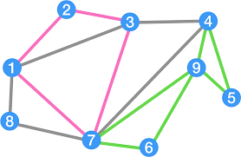

First circuit: 1-2-3-7-1-3-4-7-8-1
Second circuit: 4-5-9-6-7-9-4
Merge: 1-2-3-7-1-3-4-5-9-6-7-9-4-7-8-1

